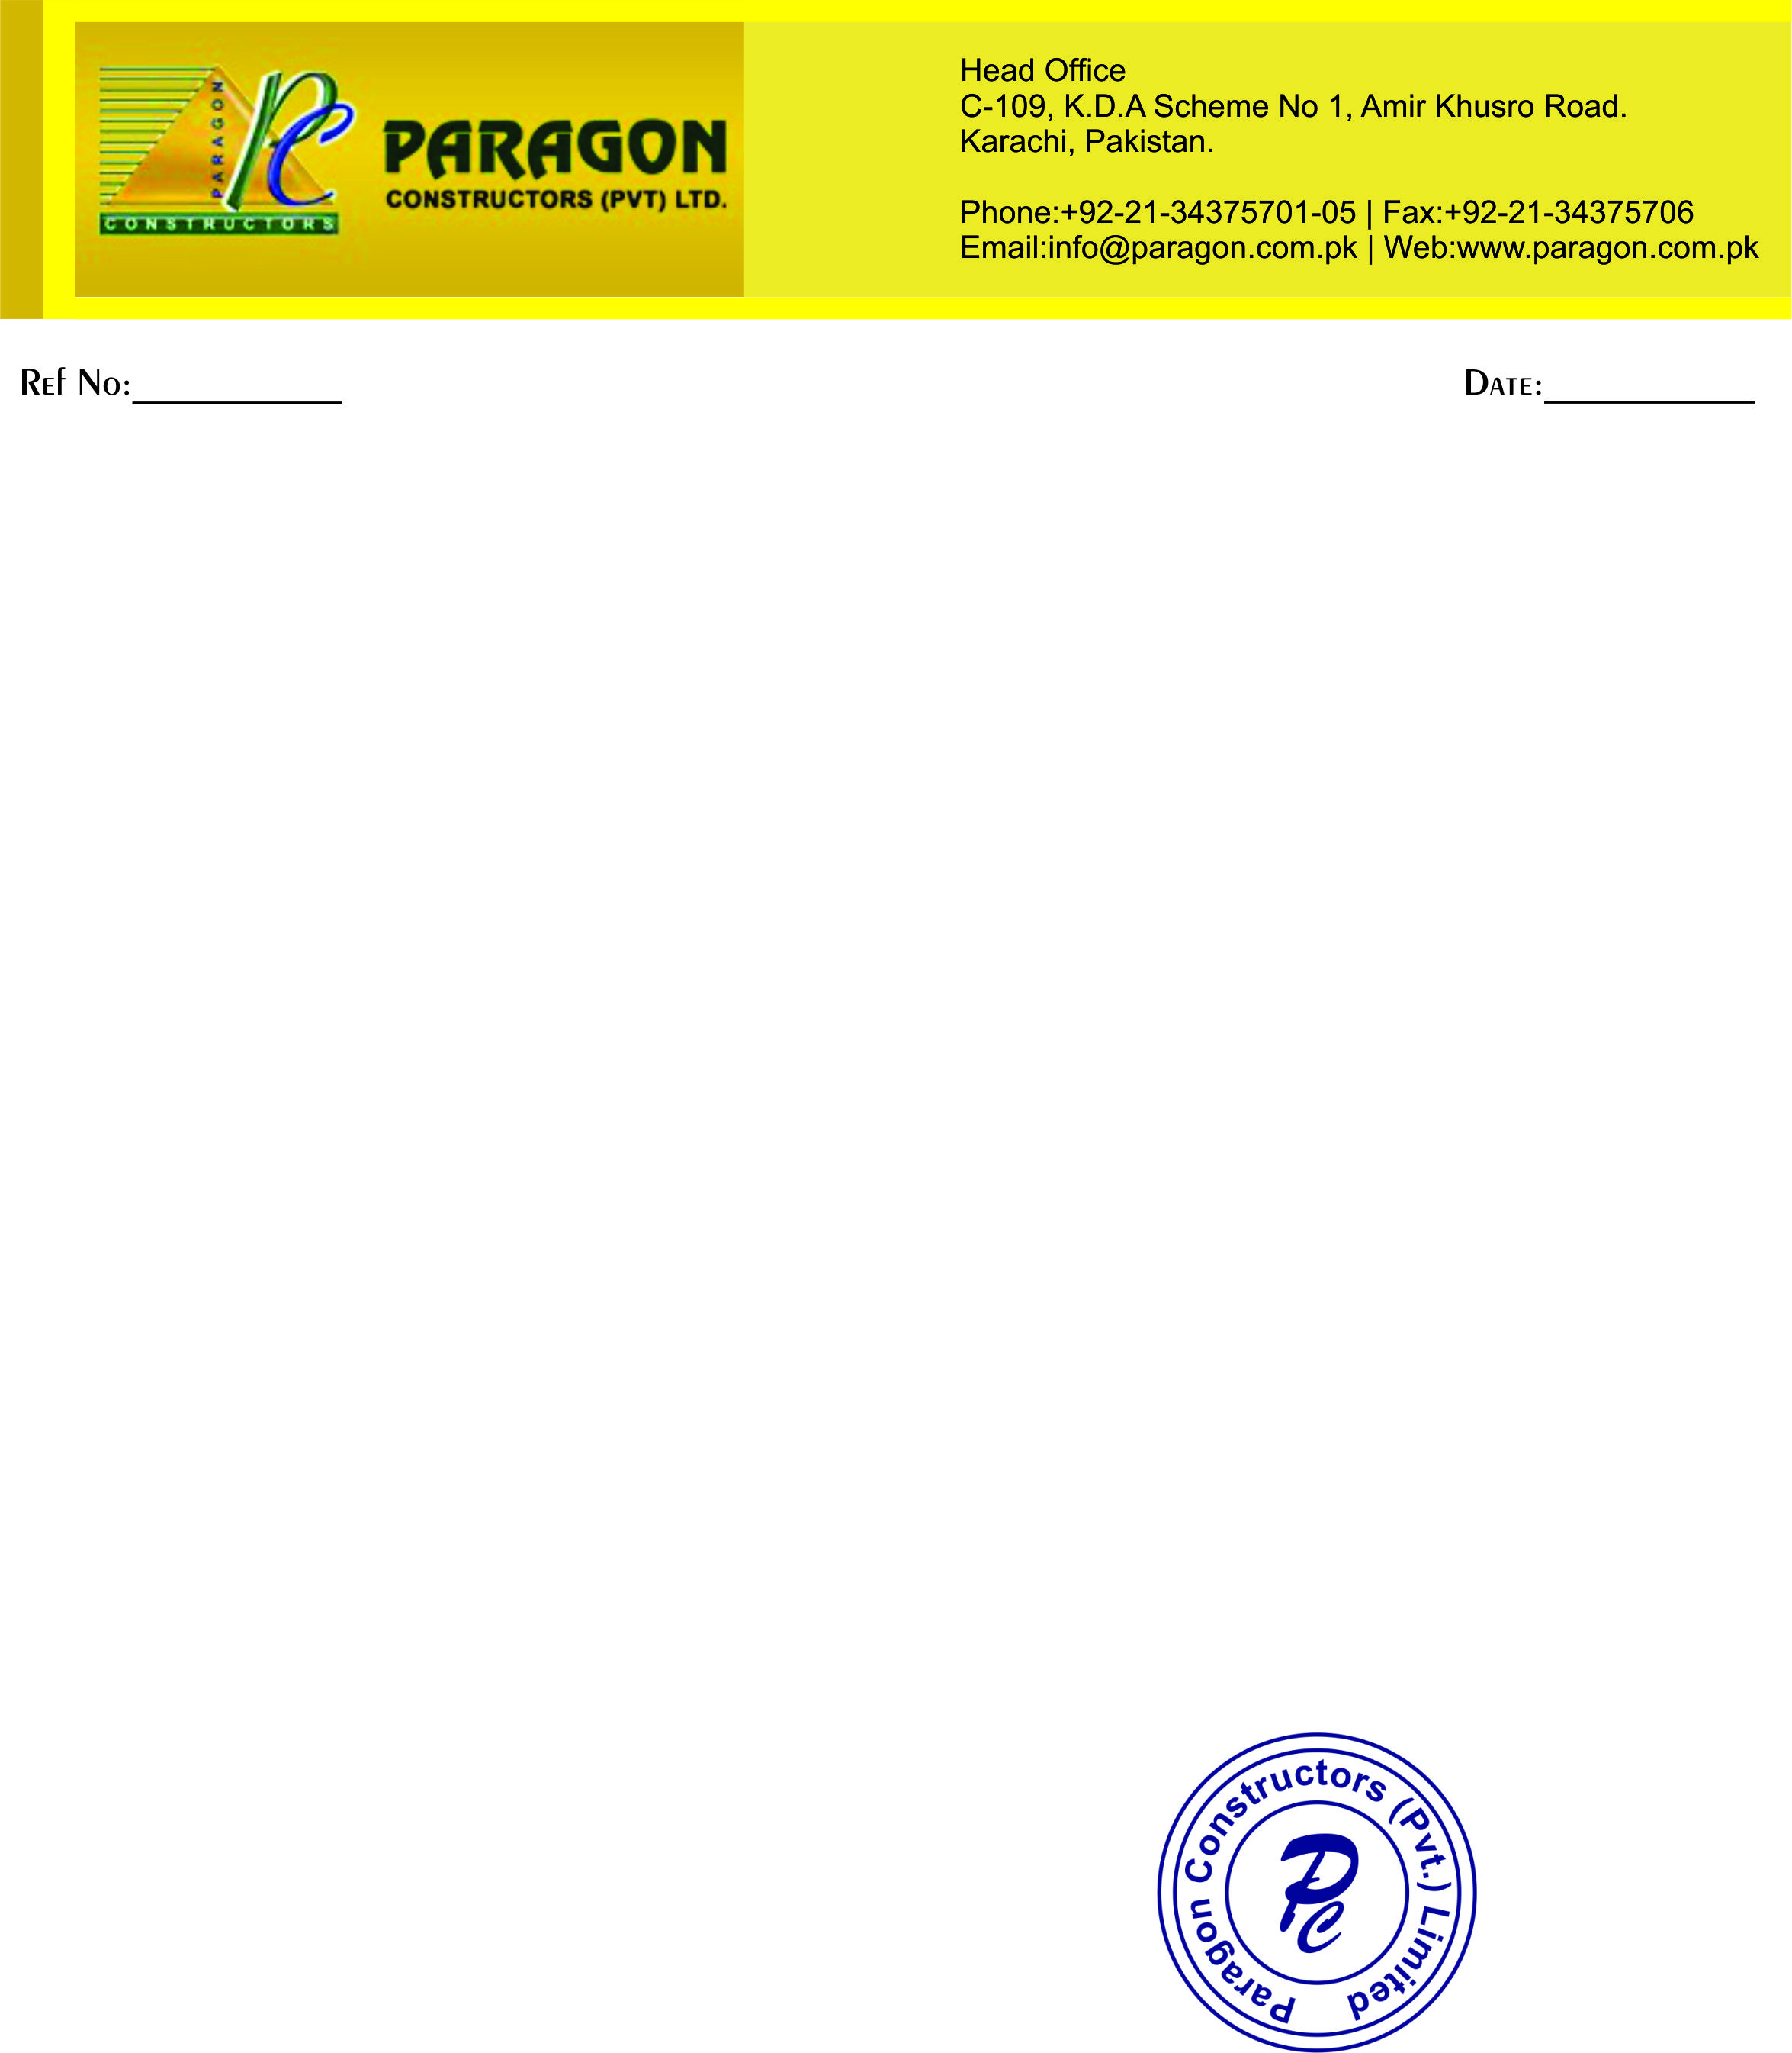

PC-22011 <To2>

**TO WHOM IT MAY CONCERN**

This is certify that Mr. <Name> S/O <fname>, was worked with us as an <Designation> for our project Lucky Cement Plant Nooriabad <From2> to <To2>.

During his tenure with us we found him very sincere, dedicated and hardworking.

We wish him all the best for his future achievements

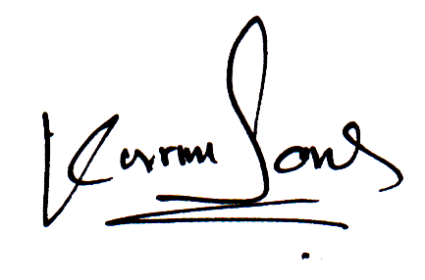

**PROJECT MANAGER**